Ultrafast Direct Electron Transfer at Organic Semiconductor and Metal Interfaces

Wei Xiong

University of California- San Diego, 92093
w2xiong@ucsd.edu

In this talk, I will give an overview of a few state-of-the-art ultrafast nonlinear spectroscopy works in my group, spanning from model electrochemical catalysis, optoelectronic devices to novel molecular photonic materials. I will particularly focus on a recent study on ultrafast direct interfacial charge transfer¹. The ability to control direct electron transfer can facilitate the development of new molecular electronics, light-harvesting materials and photocatalysis. However, it has been rarely reported, and the molecular conformation-electron dynamics relationships remain unclear. Here, we describe direct electron-transfer at buried interfaces between an organic polymer semiconductor film and a gold substrate, by observing the first dynamical electric-field-induced vibrational sum frequency generation (VSFG). In transient electric-field-induced VSFG measurements on this system, we observe dynamical responses (<150 fs) that depend on photon-energy and polarization, evidencing that electrons are directly transferred from Fermi level of gold to LUMO of organic semiconductor. Transient spectra further reveal that, although the interfaces are prepared without deliberate alignment control, a sub-ensemble of surface molecules can adopt conformations for direct electron transfer. DFT calculations support the experimental results and ascribe the observed electron transfer to a flat-lying polymer configuration in which electronic orbitals are found to be delocalized across the interface. The present observation of direct electron transfer at complex interfaces as well as the insights gained into the relationship between molecular conformations and electron dynamics will have implications for implementing novel direct electron transfer in energy materials.

References
- B. Xiang, Y. Li, C.H. Pham, F. Paesani, W. Xiong, “Ultrafast Direct Electron Transfer at Organic Semiconductor and Metal Interfaces”, Science Advances 3: e1701508 (2017).
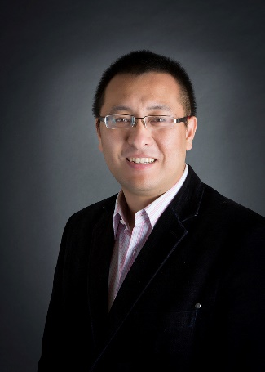
Biography
Wei Xiong is an assistant professor of Chemistry and Biochemistry at University of California- San Diego. He received his B.S. degree in Chemistry from Peking University in 2006, then his Ph.D. degrees in Chemistry from University of Wisconsin-Madison in 2011, under the supervision of Prof. Martin t. Zanni. Since 2011, he was a postdoctoral researcher in the Kapteyn-Murnane group, at JILA, University of Colorado-Boulder. Wei joined the Department of Chemistry and Biochemistry at UCSD at 2014. Wei is a recipient of prestigious awards including 2015 DARPA YFA, 2016 AFOSR YIP, and 2017 DARPA Director’s Fellowship. His research focuses on developing novel ultrafast, interfacial sensitive, optical spectroscopies and microscopies, in order to both space- and time-resolve charge and molecular dynamics in complex materials and biological interfaces. Lab website: http://ultrafast.ucsd.edu

